UNIVERSITY OF MINNESOTA

Duluth Campus Department of Studies in Justice, Culture, and Social Change 228 Cina Hall
College of Arts, Humanities, and Social Sciences 1123 University Drive
E-mail: troufs@d.umn.edu
ZOOM: https://umn.zoom.us/my/troufs
7 January 2024
Best over-all for the semester  Direct Links  to Canvas  / | Direct Links  to Canvas  / | Direct Links  to Canvas

s2024 “Sunday Memos”
s2024 Module Week 1 Modules 1-16
s2024 Simple Syllabus .pdf

Tim Roufs, Brisbane, Australia, 2017

Global Cultures Week 1

A note on ChatGPT and other AI-content Generators

1.0 What’s Happening? | 2.0 Video Explorations | 3.0 Slides  “Perennial Debates” | 4.0 Readings
5.0 *Other Assignments | 6.0 Midterm Exam | 7.0 Project | 8.0 *Discussion
9.0 (optional)  For Fun Trivia | 10.0 (optional)  Extra Credit | 11.0 (optional)  Other | (click links for details)  - = leave page
***12.0 In-the-News  Read Others’ | (optional)  13.0 Live Chat  Tuesday 7:00-8:00 p.m. | (optional)  14.0 Questions /  Comments | Items DUE this week:  *enter on-line  **upload file  ***if you signed up for this week’s news

1.0 What’s Happening Week 1?

This week we’re off to see the world, in “. . . Many Ways”. And we take a few minutes to get to know one another, and our selves, and get to know how the course is set up and operates. And we’ll take two very short, but interesting, “Selective Attention” tests to sharpen our eyes for the videos and presentations that follow in the rest of the semester.

If you haven’t read my memos . . .

“Greetings” Memo
(Textbooks)
of Tuesday, 26 December 2023,

my ”Canvas ‘Modules’ / ‘Sunday Memos’”
(General Organization of Stuff)
Memo of Thursday, 28 December 2023,

and my “Using the Canvas Modules -- REVIEW” Memo
(skip if you are comfortable using Canvas "Modules)
of Sunday, 31 December 2023,

and the “Welcome!” memo
of Wednesday, 3 January 2024)

. . . please do that as they contain useful and important information about the course that will make your life much easier.

These are not required reading,
but it would be a good idea to read them anyway.

(That’s a lot of stuff to read, but the “stuff” lightens up after next week.)

and

Compare this “Sunday Memo” with your Canvas “Week 1 Module”

REM: Links on screenshots are not “hot” (active)

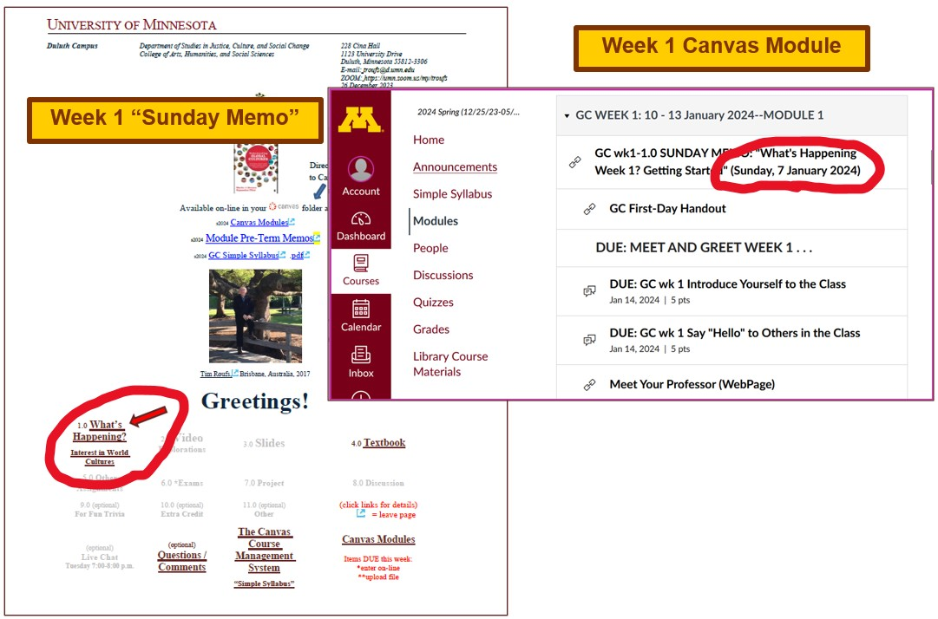

These are the two things to focus on for Week 1.
The Sunday Memo (on the left) contains details and the Canvas Module (on the right) is the basic outline.
Both contain “hot” [active] links to other materials.

Getting Started . . .

The best way to start is by having a quick look at the
"First Day Handout"
(“Class Syllabus”)
on-line at <https://www.d.umn.edu/cla/faculty/troufs/anth1095/gchandout_first-day.html> (html version).
<https://www.d.umn.edu/cla/faculty/troufs/anth1095/gchandout_first-day.pdf> (.pdf version)

REM: Links on screenshots are not “hot” (active)
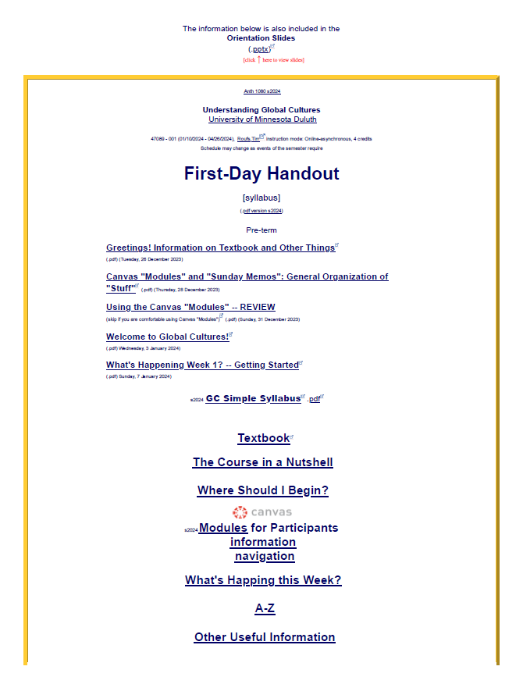

Also have a look at the course “Home” page of your Global Cultures folder <http://canvas.umn.edu/>. It will look something like this . . .

REM: Links on screenshots are not “hot” (active)

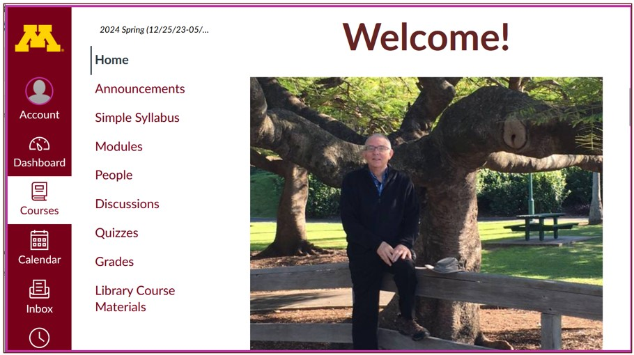

Explore the links on “Home” page . . .

REM: Links on screenshots are not “hot” (active)

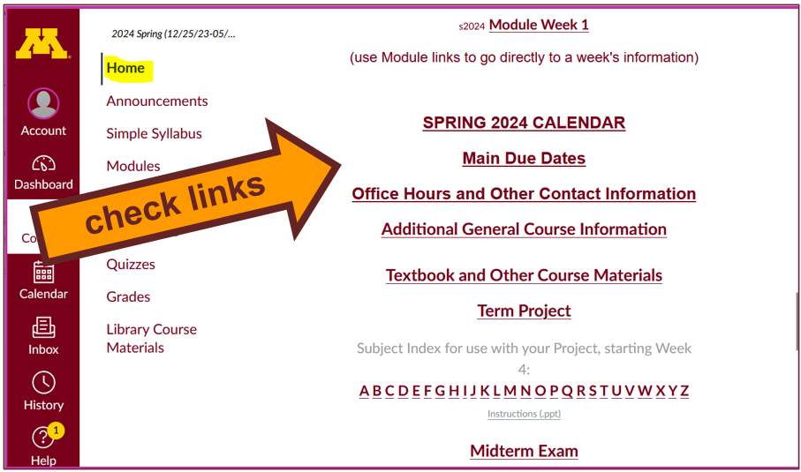

And check the links in the Modules “WEEK 1” file . . .

REM: Links on screenshots are not “hot” (active)

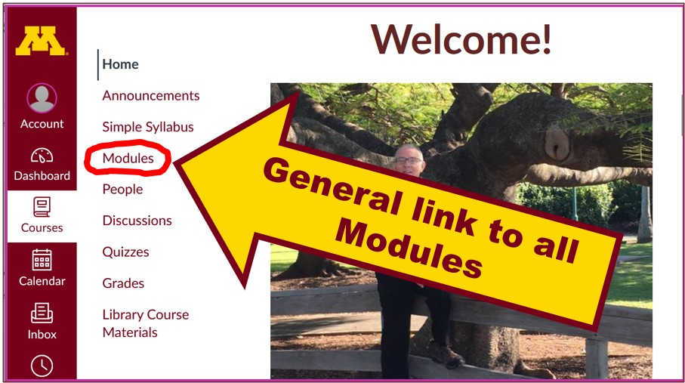
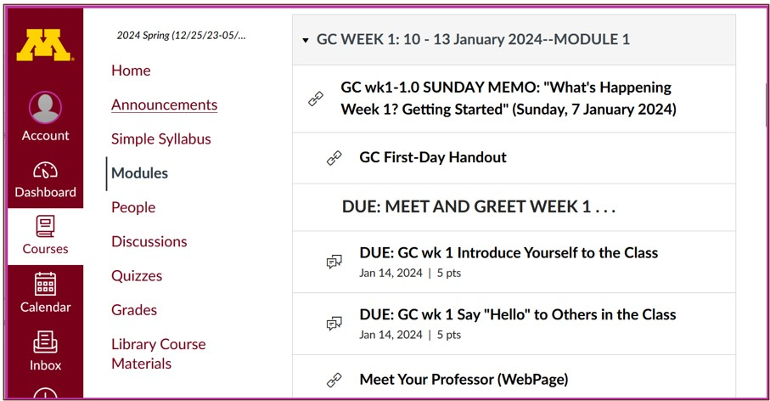

2.0 VIDEO EXPLORATIONS WEEK 1
Real People . . . Real Places . . .
Videos for the Semester

Video . . .
Many Ways to See the World
(30 min.)

on-line access
[click ↑ here]
course viewing guide

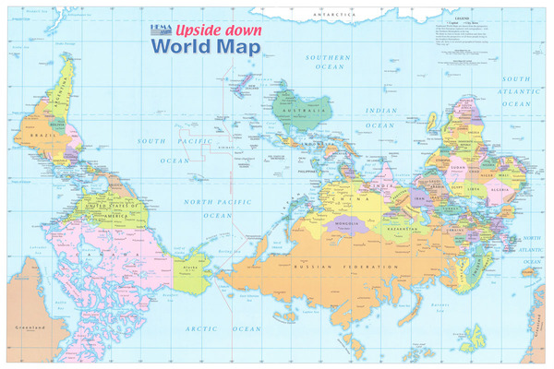
Swiftmaps

"Presents a fascinating exploration into the minds of twelve mapmakers. Discover how their unique backgrounds, philosophies, values, and politics led each to select a particular mathematical formula to create their maps. Learn about the impact those world images have had on us, consciously and unconsciously."

"Special features: Includes over 70 PowerPoint images with links to map resources; preview: Arno Peters: Radical map, remarkable man; radio interviews; book excerpts; and more."

Based on the book: Seeing through Maps / Denis Wood, Ward Kaiser, and Bob Abramms.

Video Clips . . .

Two Very Short “Selective Attention” Tests

Anthropological analytical skills include careful observation of behavior. We will be visiting many parts of the globe as we go along in the course—so you will have lots of opportunities to practice your observational skills.

So this week take the two short minute-and-a-half tests of your observational skills before you continue your intensive look at the wide variety of Global Cultures video materials that we will be viewing and re-viewing virtually every week of the semester. You should take those short tests this week.

Take the Two (Very Short)
Selective Attention Tests
in Preparation for Watching
the many Videos throughout the semester.

REM: Links on screenshots are not “hot” (active)

(Be sure to take both tests. Read the instructions carefully.)

First, take the . . .
Selective Attention Test
<http://www.youtube.com/watch?v=vJG698U2Mvo>
Read and follow the directions carefully.

(Be sure to also count the bounce passes.)

When you are finished with the Selective Attention Test, watch . . .
The Monkey Business Illusion
<http://www.youtube.com/watch?v=IGQmdoK_ZfY>
(It too is short: 1:42)
Again, read and follow the directions carefully.
(And as with The Selective Attention Test, be sure to also count the bounce passes.)

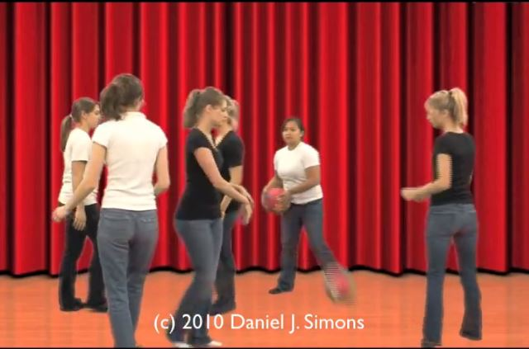

3.0 WEEK 1 SLIDES
Class Slides for the Semester

“Orientation:
Introduction to Anthropology / Orientation to the Course”
(.pptx)
[click ↑ here]

Meet Your Professor
(WebPage)
slides: (.pptx)
[click ↑ here]

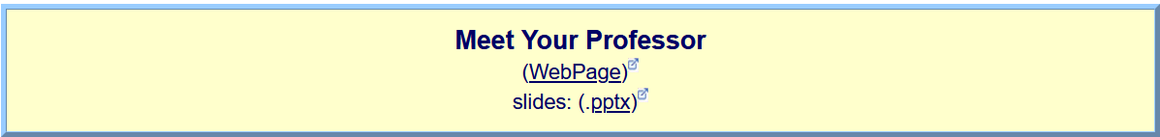

And, if you want, you can have a look at future attractions:

4.0 READINGS FOR WEEK 1
Textbook Information
Readings for the Semester

REM: Links on screenshots are not “hot” (active)

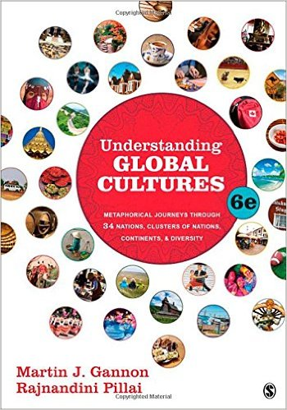
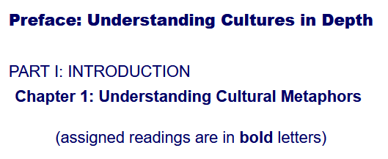

5.0 OTHER ASSIGNMENT INFORMATION
Main Due Dates
s2024 Module Week 1

From your Home Page,
click on the Modules feature to start out . . .

REM: Links on screenshots are not “hot” (active)

. . . and that wll take you to the Modules folder, which looks something like this . . .
↓

REM: Links on screenshots are not “hot” (active)

Use the “Collapse All”
button in the upper right-hand corner
to de-clutter your screen.

That will make your life much easier.
(Trust me.)
↓

(Sorry; Canvas does not permit instructors to set the default to open with all modules closed.)

REM: Links on screenshots are not “hot” (active)

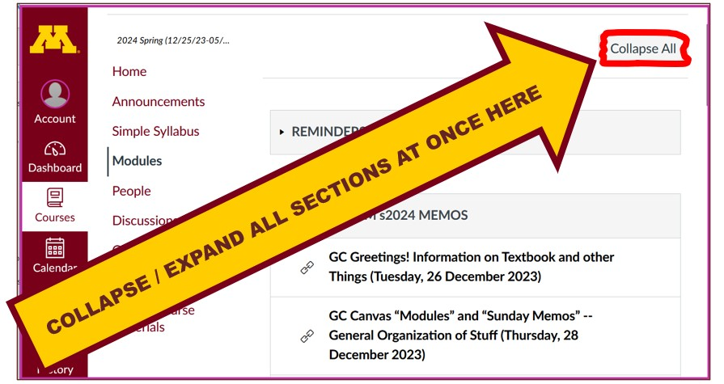

And your de-cluttered Canvas “Modules” folder
will then look something like this . . :
↓

REM: Links on screenshots are not “hot” (active)

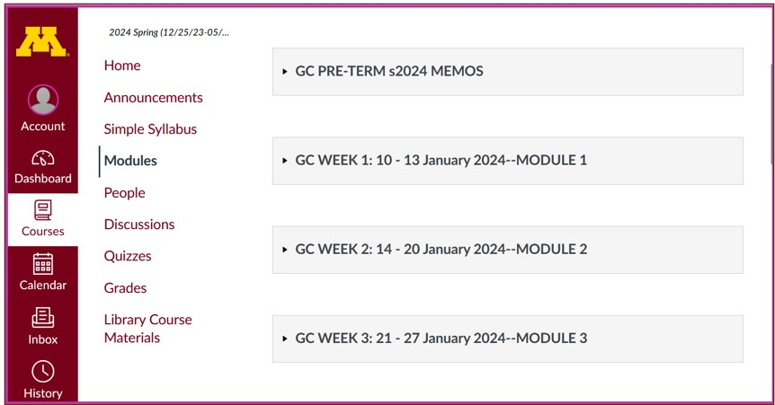

Then open the Module of the week
that you want to look at . . :

REM: Links on screenshots are not “hot” (active)

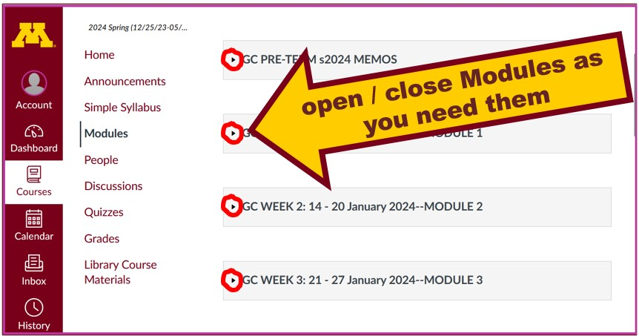

And the Week 1 Module will look like this . . .
↓

REM: Links on screenshots are not “hot” (active)

OTHER ASSIGNMENT INFORMATION (cont.) . . .
Main Due Dates

Be sure to check the details of the activities and assignments each week in your folder.

Self-Assessment

This week please take a short survey to give us an idea of what your views and takes are on Global Cultures. Once everyone has completed this feedback, everyone will be able to see the results.

Before you get deep into the course, briefly describe your experiences with and ideas about Global Cultures, and what you already know about things related to Understanding Global Cultures.

At different points during the semester we will return to these questions to have a look at the various subjects.

REM: Links on screenshots are not “hot” (active)

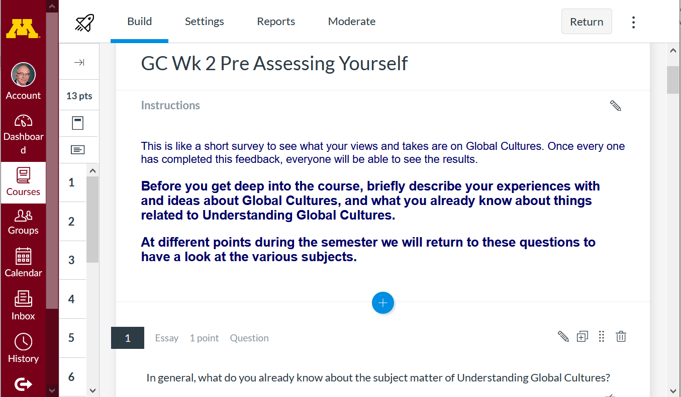

s2024 <https://canvas.umn.edu/courses/405175/modules/items/11140653>

6.0 MIDTERM EXAM WEEK 1 . . .
General Midterm Exam Information

7.0 PROJECT INFORMATION . . .
Basic Information
Main Due Dates

We’ll have a look at some Project information next week

8.0 DUE: DISCUSSION WEEK 1 . . .
(optional) Online Discussions Information, Rubric, and Sample Posts

Introduce yourself and say “Hi.”

MEET AND GREET (Week 1)

Meet Your Classmates:
Introduce Yourself to the Class

(if you haven’t already done so)

REM: Links on screenshots are not “hot” (active)

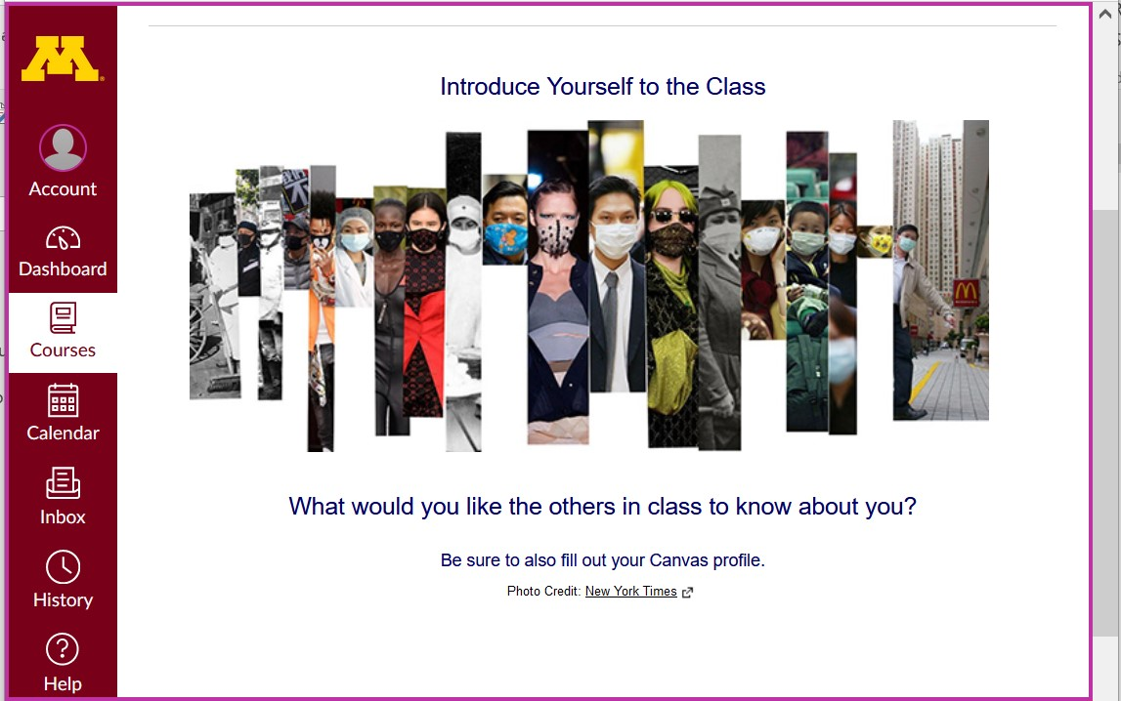

s2024 <https://canvas.umn.edu/courses/405175/modules/items/11140589>
[click ↑ here]

Say "Hello" to Others in the Class

(if you haven’t already done so)

REM: Links on screenshots are not “hot” (active)

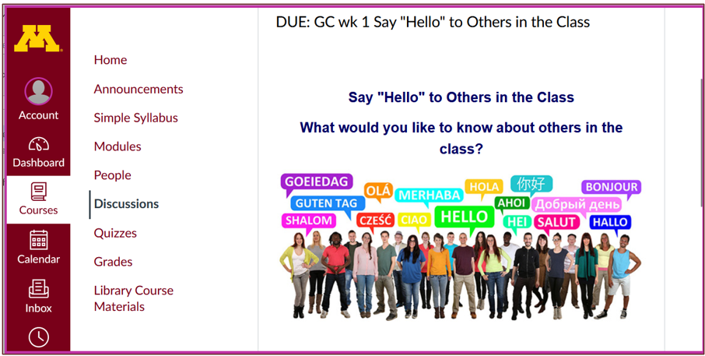

^{Photo Credit: New York Times}
s2023 <https://canvas.umn.edu/courses/405175/modules/items/11140590>
[click ↑ here]

and

Meet Your Professor
[click ↑ here]

If you are curious about me, more than you probably want (or ought) to know is available on the Meet Your Professor page <http://www.d.umn.edu/cla/faculty/troufs/MeetYourProfessor.html>. More that you or anyone needs to know is available, with some nice photos, at <http://www.d.umn.edu/~troufs/anthfood/PowerPoint/af-meet_your_prof.pptx>

A while back one of the students seemed to especially like the part where the older folks in my hometown of Winsted, MN, talk about the time I burnt the Town Hall by my dad's restaurant down (which I didn't, I only burnt half of the back side off.)

REM: Links on screenshots are not “hot” (active)

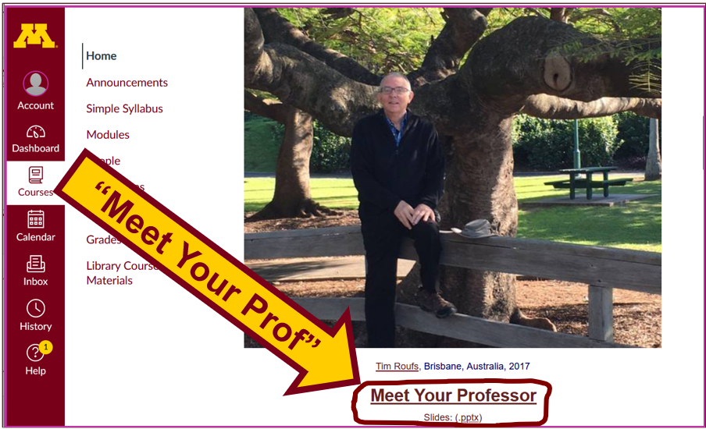

(optional) 9.0 FOR FUN TRIVIA
Trivia HomePage

The citizens of what country complain
that their country keeps getting left off of maps?

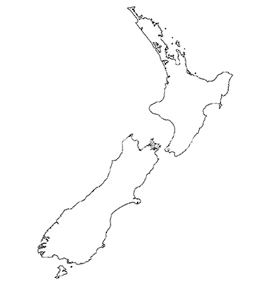
Answer

(optional) 10.0 EXTRA CREDIT . . .
Basic Extra Credit Information

Extra Credit is available in this class.
We’ll have a closer look at Extra Credit after the Midterm Exam.

11.0 OTHER (optional) . . .

From time to time during the semester other optional opportunities will be listed here.

12.0 IN-THE-NEWS WEEK 1
Media Bias Chart
Fake News

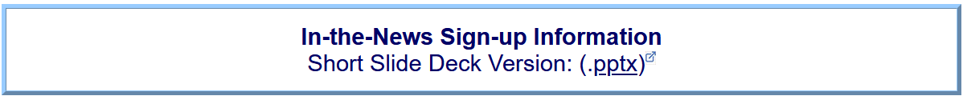

News Reports start Next Week.

Be Sure to Sign Up in your Course Google Drive Folder:
s2024 external <https://docs.google.com/document/d/1YJQhgrVe8wHK00nwGzC3gQ40Z4oKzxRgOZO5QZNufPw/edit?usp=sharing>
[click ↑ here]

(optional) 13.0 LIVE CHAT: OPEN FORUM / OFFICE HOURS . . .
Contact Information

Tuesday, 7:00-8:00 p.m. (CDT)
“ZOOM”
[click ↑ here]
or
e-mail anytime: mailto:troufs@d.umn.edu
[click ↑ here]

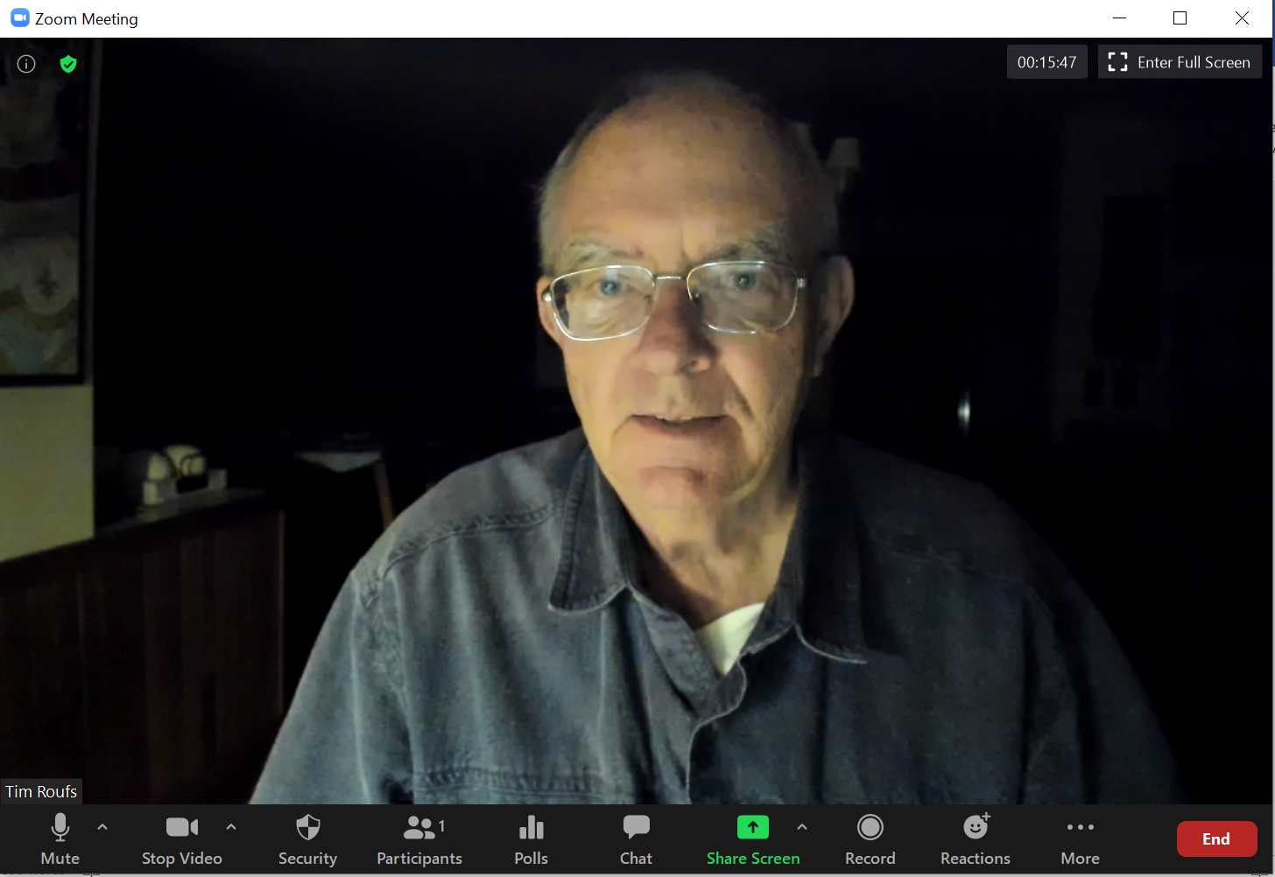

Live Chat is optional.

14.0 QUESTIONS? / COMMENTS . . .

If you have any questions or comments right now, please do not hesitate to e-mail troufs@d.umn.edu, or ZOOM https://umn.zoom.us/my/troufs. (E-mail is fastest, and most generally best as quite often URLs need be sent.)

Best Wishes,

Tim Roufs
<http://www.d.umn.edu/~troufs/>
<https://umn.zoom.us/my/troufs>
<other contact information>

P.S. REM: If you are new to the world of "technology" don't worry too much about that. Things may not "work" for you at first, but hang in there and we'll help you along. If you have not used course management system before, you might find it helpful to view the Canvas Student Guide.

